2.9 - Labs (5)

* Lab 2.9.8 (4) Evaluating different kinds of means [B]

#include <iostream>

#include<cmath>

#include<cstdlib>

using namespace std;

int main()

{

setlocale(LC_ALL, "RUS");

double sum = 0, sum1 = 0, d = 1, sum2 = 0;

double a[] = { 1., 2., 3., 4., 5. };

int n = sizeof(a) / sizeof(a[0]);

double ArithmeticMean;

double HarmonicMean;

double GeometricMean;

double RootMeanSquare;

for (int i = 0; i < 5; i++)

{

sum += a[i];

sum1 += 1 / a[i];

d *= a[i];

sum2 += pow(a[i], 2);

}

ArithmeticMean = sum / n;

HarmonicMean = n / sum1;

GeometricMean = pow(d, 0.2);

RootMeanSquare = sqrt(sum2 / n);

cout << "Arithmetic Mean = " << ArithmeticMean << endl;

cout << "Harmonic Mean = " << HarmonicMean << endl;

cout << "Geometric Mean = " << GeometricMean << endl;

cout << "RootMean Square = " << RootMeanSquare << endl;

cout << endl;

system("pause");

return(0);

}

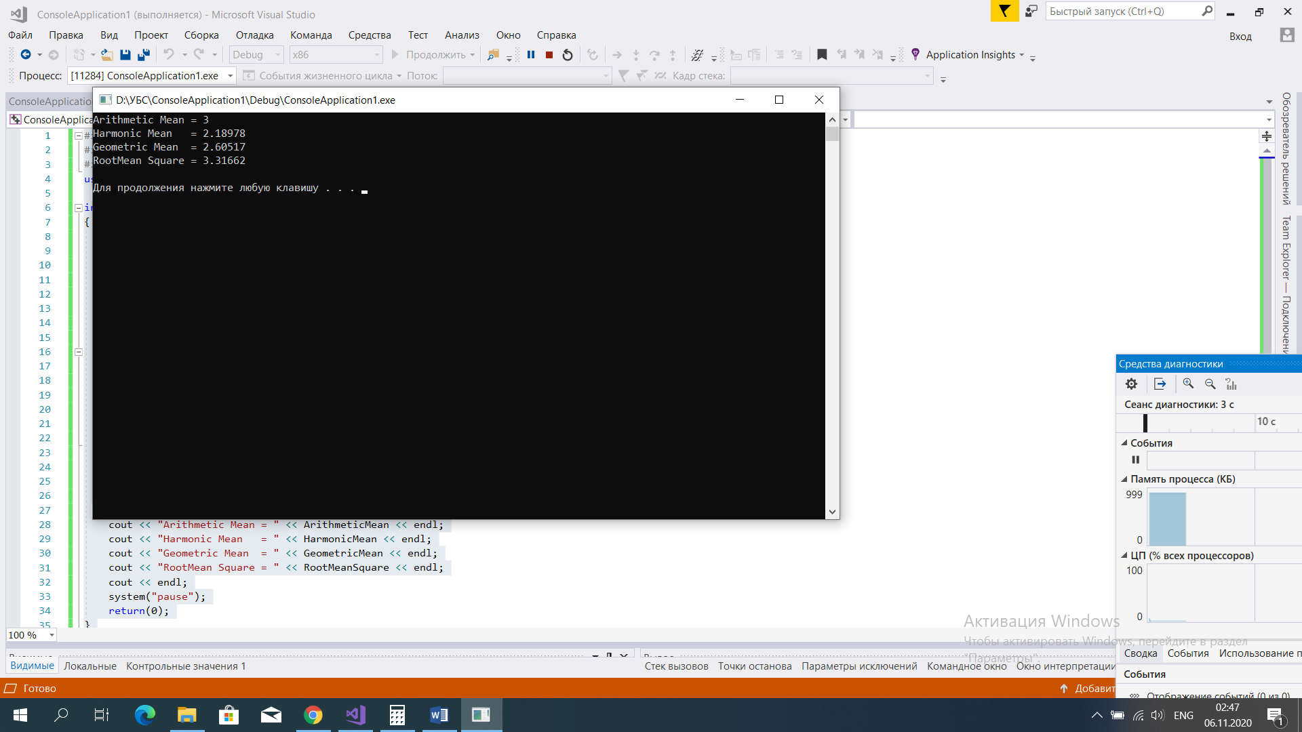

* Lab 2.9.8 (5) Two dimensional square array - symmetric or not? [B]

#include <iostream>

#include<cmath>

#include<cstdlib>

using namespace std;

int main()

{

setlocale(LC_ALL, "RUS");

double matrix[][4] = { { 1, 2, 3, 4 },

{ 2, 2, 3, 1 },

{ 3, 3, 3, 2 },

{ 4, 1, 2, 4 } };

int side = sizeof(matrix[0]) / sizeof(matrix[0][0]);

bool issymmetric = true;

for (int i = 0; i < 4; i++)

{

for (int j = 0; j < 4; j++)

{

if (i != 4 && matrix[i][j] != matrix[j][i])

issymmetric = true;

}

}

if (true)

cout << "The matrix is symmetric" << endl;

else

cout << "The matrix is not symmetric" << endl;

system("pause");

return(0);

}

